Summary of Speed Indicator Device (SID) Activity
For the Period 17th December 2022 to 12th February 2023

Location: From 17th December 2022 until 16th January 2023 the SID was positioned on the Stratford Tony Road in the 40 mph speed limit zone. The SID was mounted on a relocatable post on the left side of the road as you enter the village from Stratford Tony. This site is the Stratford Tony Road, Primary site. The device was moved on 23rd January 2023 to the Blandford Road (A354), in the 30 mph speed limit zone. The SID was mounted on a moveable post on the left side of the road as you enter the village from Blandford. This site is referred to as the Blandford Road, Primary site.

For further information regarding approved SID sites in Coombe Bissett and Homington villages please refer to the SID location Power Point guide.

Period 17th December 2022 to 16th January 2023
Location: Stratford Tony Road site, 40 mph speed limit zone. The SID was facing traffic entering the village.

Traffic vs. SID | Towards | Away
Traffic in relation to the village | Incoming | Outgoing
Average Speed (mph) | 34.06 | 34.62
Maximum Speed (mph) | 81.00 | 71.00
Traffic Volume (# vehicles) | 37,688 | 28,231
% Less than 47 mph* | 96.93 | 96.85
85th %ile Speed (mph) | 39.00 | 39.00
* Police enforcement in a 40 mph limit is liable at or above 47 mph

The last time the SID was at this location was between 5th July and 2nd August 2022 when it was also facing traffic entering the village. Inbound average speeds have remained constant, outbound traffic has slowed, marginally. Both are well below the speed limit at this location. Maximum speeds are also very similar to the previous session at this site. It is noted that the percentage of inbound vehicles travelling at 46 mph or less has deteriorated slightly (by 1.71%). The percentage for outbound traffic marginally improved. When calculated as a daily average, Vehicle volumes are down 19% (inbound) and 30% (outbound) compared to last summer. This is may be due to seasonal holiday traffic variances. Reduced traffic volumes normally mean speeds increase. The fact that they are relatively stable is another positive.

Period 24th January to 12th February 2023
Location: Blandford Road Primary, 30 mph speed limit zone. The SID was facing traffic coming into the village from Blandford.

Traffic vs. SID | Towards | Away
Traffic in relation to the village | Incoming | Outgoing
Average Speed (mph) | 30.96 | 33.83
Maximum Speed (mph) | 79.00 | 79.00
Traffic Volume (# vehicles) | 41,118 | 56,393
% Less than 25 mph* | 79.26 | 64.69
85th %ile Speed (mph) | 37.00 | 40.00
* Police enforcement in a 30 mph limit is liable at or above 36 mph

The last time the SID was at this location was between 8th and 30th March 2022. The latest statistics for average speeds, percentage distribution and 85th percentile speeds are similar to those reported previously. Maximum speeds have reduced marginally, particularly for outbound drivers. The percentage of outbound drivers keeping to within 36 mph has also increased slightly (by 2 %). Vehicle volumes show an increase in traffic: Inbound traffic has increased 5.7% and outbound traffic 6.9%. We have now received approval to start Community Speed Watch sessions adjacent to this SID site, at the entrance to Wings Dairy. We hope to conduct our first session at this location in the next week or so.

Detailed PDF reports:
Please refer to the respective tabs for Stratford Tony Road and Blandford Road for more detailed analysis of traffic data recorded by the SID, which is presented in PDF report format. Guidance Notes to each section of the PDF reports are provided below this summary.
Note: Our SID does not have GPS and therefore its reports are location agnostic. References in reports to Incoming and Outgoing traffic refer to traffic coming towards the device (Incoming) and traffic going past the device in the opposite direction (Outgoing).

Wiltshire Speed Indicator Device Data Sharing Pilot
The Governance Forum of the SID Data Pilot held a meeting on 27th January and agreed that members of the Pilot Group could start sharing data from their SIDs with effect from 31st January.
Here is a graphic representation of how the process works – for communities with Elan City Evolis SIDs.
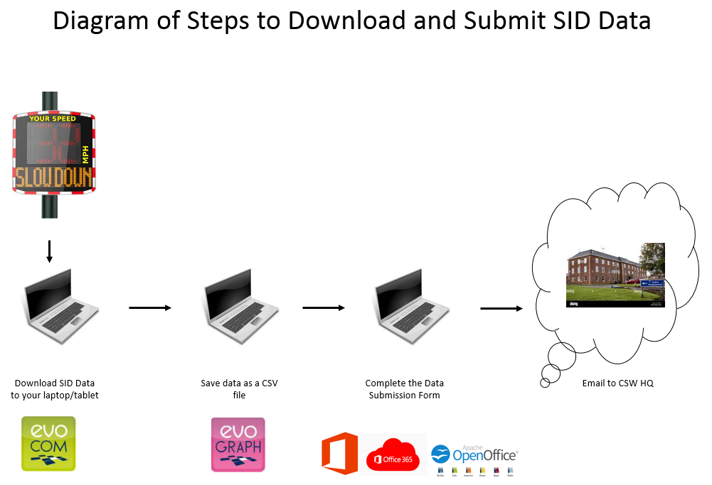
There is a total of 11 SIDs in the Pilot group who have initially shared 14 sets of data for the month of January.
And this is a summary of progress to-date.
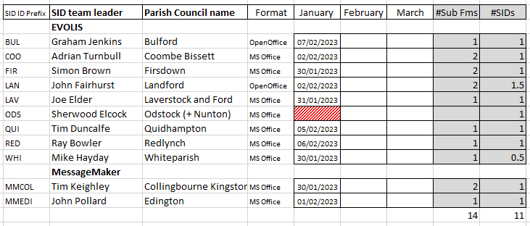
February data is due to be loaded between 22nd and 28th February, and then March data will be loaded between 25th and 31st March. The Governance Forum will then meet to review the Pilot status against the original objectives set out in the Terms of Reference document.
Depending on the success of the Pilot, a decision will then be made whether to make a presentation to Wiltshire Police ELT with a view to rolling out SID Data sharing to other SID communities in Wiltshire.
Coombe Bissett Community Speed Watch (CSW)

A total of 16 speedwatch sessions were conducted between 8th December 2022 and 10th February 2023.
Sessions held between 08 12 2022 and 10 02 2023
Location | Checks | Vehicles | Speeders | %
Deegan House | 7 | 3,112 | 119 | 3.8%
Hunter’s Lodge | 0
Water Lane | 0
Tottens Farm | 3 | 193 | 15 | 7.8%
Homington. | 6 | 430 | 22 | 5.1%
 | 16 | 3,735 | 156 | 4.2%

The number of CSW sessions conducted during the period were impacted by the Christmas and New Year holidays (no sessions were scheduled between 22nd December 2022 and 19th January 2023). In addition, two morning sessions which were due to take place at Tottens Farm had to be cancelled due to Fog (while visibility may be adequate for us to see, the Unipar Laser speed device we use will not function if the amount of moisture particles in the air is beyond a certain level. And lastly the closure of Homington Road between Shutts Lane and the Old Vicarage 13th – 17th February has meant that sessions at Tottens Farm and Water Lane have had to be cancelled.

We have been advised that our requests an additional CSW site at the entrance to the driveway next to the old temporary bus stop on Salisbury Road (A354), at the East end of the village will be dependent on the completion of a Traffic Survey. A request for a survey was submitted to the Parish Council on 2nd November 2022 and we are still waiting for Wiltshire Council Highways Dept to advise when they can schedule a survey.

Sarah Holden of CSW HQ has conducted two more drop-In sessions for all Community Speed Watch team members across Wiltshire on 31st January. Please have a look at the presentation in the attached link which highlights various initiatives which Wiltshire Police and Wiltshire’s Police and Crime Commissioner have undertaken to improve Road Safety on our roads.

In the meantime, our CSW team endeavours to cover as much of the community as possible. However, the number of sessions we can handle is dependent on the size of our team. Unless more members of the community are willing to give up a few hours a month to help with more sessions we can only commit to an average of 3 sessions a week. If would like to find out more about Community Speed Watch and help us in our efforts to improve road safety in the parish, please don’t hesitate to either call Adrian Turnbull on 07747 620210 or email me at turnbull_adrian@hotmail.com .

Thank you!

